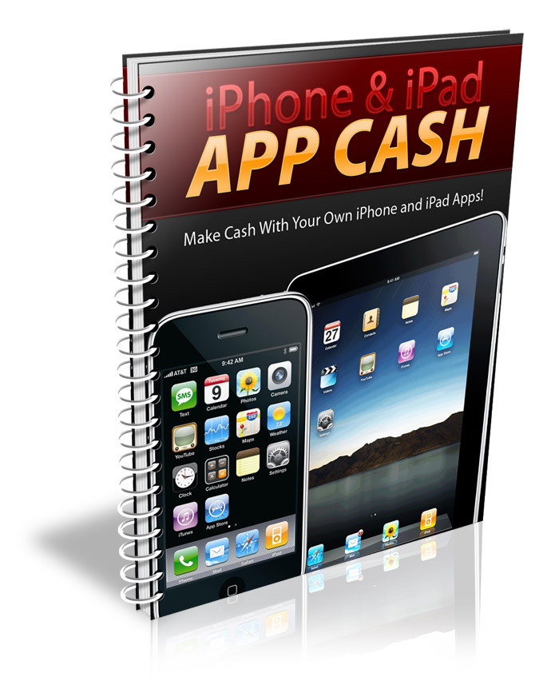
Table of Contents
Introduction 3
Generating App Ideas 4
Copy Existing Apps 4
What do YOU Need? 5
Outsourcing Development 6
Software and Services for Development 8
Marketing an App 9
Forum Marketing 9
Press Releases 10
Blogging 10
Resources 11

Introduction
There are many people who are making millions of dollars with applications for the iPhone and iPad. Fortunately, many iPhone apps will also work for the iPad, so you can kill two birds with one stone.
There is never going to be a better time than now to be an app developer. While the field is constantly becoming more and more competitive, the market is still relatively young. If you get in now, you have a very good chance to make a lot of money. Remember, the pioneers in an industry usually establish dominance right away, so it’s important to jump in right now!
In this report, I’m going to teach you some of the basics of creating an iPhone or iPad app. I’ll also give you some resources with more advanced information.
The time to do this is NOW! The longer you wait, the more money you are leaving on the table!

Generating App Ideas
Generating an idea for an app will probably be your biggest hurdle, and that can easily be overcome with some creative brainstorming techniques.
Remember, an app doesn’t even have to be useful or involved in order to be successful. Have you heard of Joel Comm’s app? It’s called iFart. Basically, it lets users choose from several different types of farting sounds and play them through their phone. It’s useless, but it has been downloaded many, many times. At about 99 cents per download, it has made back his development costs many times over!

Copy Existing Apps
One of the easiest ways to get an idea is simply by looking through popular apps and copying them. Obviously, you wouldn’t want to copy their concept exactly. Instead, download the app yourself and try to figure out its major weaknesses.
If possible, look for comments about that app. Find out what people don’t like. Then you can create an app that addresses those weaknesses in order to make customers happier with your app than the original!
Some of the world’s best products are simply copies of existing products. Today’s computers are just copies of the original PC – with significant improvements, of course. There’s nothing wrong with taking ideas as long as you make major changes and make the product unique in several ways.

What do YOU Need?
Maybe there’s something you wish your own iPhone could do that you haven’t seen addressed in an app. This is great, because if you want this, other people probably do, too!
Make a list of some of the things you would love to be able to do with your phone, and then search the App Store to see if an existing app will do it. If not, you might be able to create the first one! If so, you can always copy and improve it!

Outsourcing Development
You don’t have to worry about a lack of programming experience. Even if you have never written a line of code in your life, you can still release successful apps.
The main way to create apps without programming is to outsource the development. If you have a very specific ideas for your app, this may be your only option.
Make sure you hire someone who has significant experience creating iPhone and iPad apps. Many programmers think they know how to create an app, but soon discover it’s more complex than they thought. You should be certain to hire someone who has already created apps that work on the iPhone and iPad, and who can show you examples.
Never pay 100% of the development cost up front! Try to pay a 10% to 25% deposit. If the programmer has excellent, verifiable references, you might go as high as 50% up front. You never want to risk paying 100% up front, no matter how impeccable their references are. What if (God forbid) they passed away during development? Anything can happen.
In order to ensure you get the app you really want, be sure you have as many details as possible about the app before you start looking for a programmer. You will want to map out functionality, screen layouts, etc. so the programmer knows exactly what you want before work starts. This will save you both a lot of time, money, and frustration.
Also, be certain to get your programmer to sign an NDA and a NCA. An NDA is a non-disclosure agreement that ensures they won’t talk to anyone about your app, potentially opening you up to competition before your app is even available. An NCA is an agreement that the developer won’t release an app that competes with yours, and can also prevent them from developing a similar app for someone else for a period of time. An attorney can help you draw up these agreements. You may even want to get an NDA while in the hiring process so you can talk about your app in detail to ensure the programmer is confident they can do what you want before you hire him or her.

Software and Services for Development
If you have an app idea that is very simple, you may be able to use one of the ready-made solutions that are now available to build your app. These programs and services can create very simple apps for as little as $30!
Don’t expect to get a custom app that will perform specific functions for this price. But you could, for example, get an app that would deliver news and updates from popular golf blogs and news sites by RSS. Golf fans might be willing to pay 99 cents for an app that would give them the latest news in the world of golfing at their fingertips.
Services include:
http://www.AppIncubator.com
http://www.Kanchoo.com
http://www.MyAppBuilder.com
http://www.BuildAnApp.com

Marketing an App
Many app developers erroneously believe that all they have to do is upload their app to the App Store and sales will magically begin to flood in. This might happen, but it is extremely unlikely. The App Store is becoming more and more competitive all the time, and you must promote your app if you want to ensure significant sales.
There are practically endless ways to promote an app, but I’m going to go over some of the best ways to get an app off the ground quickly.

Forum Marketing
One of the best places to market your app is via forums in your app’s niche. If you have a golf app, why not market it through golfing forums?
You definitely do not want to spam your app. Instead, sign up to the forum and place something like this in your signature file (usually found in your preferences or control panel.)
“Jim Smith – Creator of the Golf News Blast app for iPhone and iPad”
If the forum allows links in signatures, you can also place a link to your app in your signature.
Then all you have to do is post on the forum. Post helpful tips and advice, answer questions, and be friendly. As you become more well-known, more people will notice your signature and word will spread about your app.

Press Releases
A press release is a great way to go, especially if you have an app that is very unique. If you can get picked up by major news outlets, you could get a lot of publicity very quickly!

Blogging
If you have a blog in your app’s niche, make sure you post about it regularly. If not, consider commenting on popular posts on other blogs in your niche!

Resources
If you want more in-depth information about making money with iPhone and iPad apps, I highly recommend the following products.
Earn with Apps – This is the quintessential guide to making money with your own iPhone and iPad apps! From A-Z this system will teach you exactly how to get started!
Create Apps with No Experience – If you want to create apps yourself, this is THE guide for you! Learn exactly how to create iPhone and iPad apps without any prior experience or programming knowledge!
How to Market iPhone Apps – Do you need more ideas for marketing your app? This guide will teach you everything you need to know to send your sales through the roof!

